**Assignment :01**

**Report on Industry Visit to Sri Dharmasthala Siri Gramodyoga Samsthe (R)**

Date of Visit: July 10, 2024Location: T.B Cross, Laila Post & Village, Belthangady (Tq),

Karnataka-574214

Organized by: Computer Science Department, SDM Polytechnic, Ujire – 574 240 cohort owner : Mr. Varadaraj A S

* Mr. Thribhuvan
* Mr. Varadaraj A S
* 64 Students from the Final Year Computer Science Engineering Department

# Introduction

The textile industry in Ujire, TB Cross, is a modern facility that has recently integrated automated machinery. This advancement, implemented a few months ago, has significantly enhanced efficiency and productivity.

## Operations and Production

### Automation Implementation

The facility has recently integrated automated machinery, which has significantly enhanced the efficiency and productivity of the textile manufacturing process.

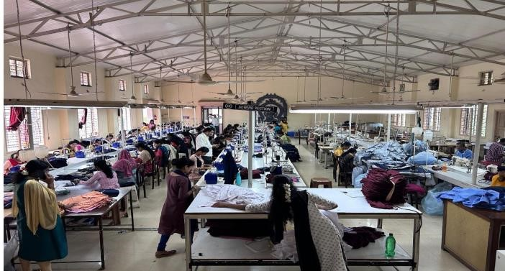

Production Division:

**Getting Materials**: Buying raw materials like cotton or wool from local farmers.

**Making Yarn**: Turning these materials into yarn.

**Weaving or Knitting**: Using machines to create fabric from yarn.

**Adding Color**: Coloring or printing designs on the fabric.

Processing Division:

**Finishing Touches**: Making fabrics softer or more durable.

**Checking Quality**: Making sure fabrics are good enough to sell.

**Packing**: Getting fabrics ready to send to customers.

Sales and Marketing Division:

**Finding Buyers:** Figuring out who wants to buy the fabrics.

**Selling Strategies:** Deciding how to sell the fabrics to stores or directly to people.

**Helping Customers:** Talking to customers and making sure they're happy.

Logistics and Distribution Division:

**Keeping Track:** Making sure there's enough fabric to sell.

**Getting Things Where They Need to Go:** Sending fabrics to stores or customers.

**Storing Fabric:** Keeping fabric safe until it's sold.

Finance and Administration Division:

**Managing Money:** Keeping track of how much money is coming in and going out.

**Taking Care of People:** Hiring workers and making sure they have what they need.

**Following Rules:** Making sure the company follows all the rules and laws.

Research and Development (R&D) Division:

**Making New Things:** Creating new fabrics or finding better ways to make them.

**Testing:** Trying out new ideas to see if they work.

**Helping the Environment:** Finding ways to make fabrics that are good for the environment.

Corporate Social Responsibility (CSR) Division:

**Helping Out:** Doing things to help the community where the company works.

**Doing Things Right:** Making sure workers are treated well and everything is fair.